1. The following projects have debug statements that are printed to a file. To put these projects in debug mode see Appendix 1.
   1. Arb(1445)
   2. 1553
   3. PCI Serial
   4. Can
   5. Gigabit
   6. Counter Timer(1420)
   7. DSO(HP1428)
   8. DSO(ZT1428)
   9. Function Generator
   10. Function Generator A or B version
   11. Power Supplies
   12. VEO2

Note: Additional Instruments can be added if/when needed.

1. Putting the system in CEM Debug
   1. Navigate to the Bus Config File
      1. C:\usr\Tyx\sub\IEEE716.89\GPATSCIC\Stattion
   2. Find the instrument you want to put into Debug and type DBG 10 next to that instrument

Note: See picture below. If this is done incorrectly then you will get an error. The Test Program must be unloaded and reloaded.

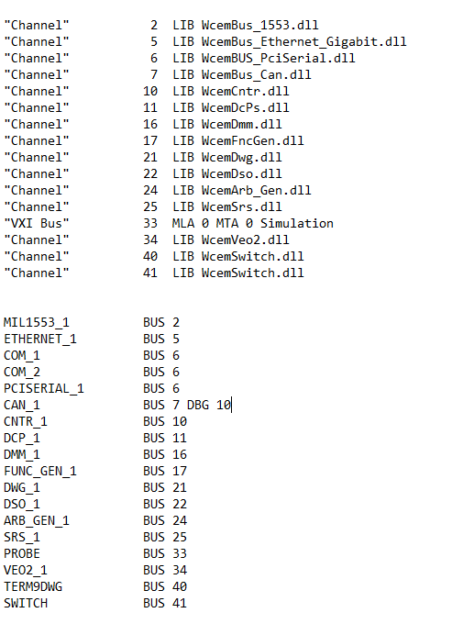

1. Putting the system in ATXML Debug
   1. Navigate to TestStationInstance.xml
      1. C:\Program Files (x86)\ATS\ISS\config
   2. Find the Instrument you want to put into debug and change the debug level to 10

Note: See picture below. The system must be restarted after this.

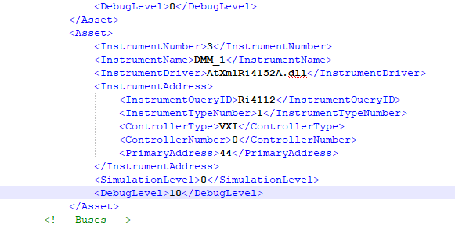

Note: To put the system in simulation you would change the Simulation Level instead.

Appendix 1: How to put ATXML projects in debug to get debug file

1. Navigate to C:\aps\data on the controller
2. Use table in Step 5 below to find name of file to be created
3. Create a file with the name found in step 2.

NOTE: The file must have no extension

* 1. Example for the VIPER/T DSO create a file named DEBUGIT_ZT1428.
     1. Right click inside C:\aps\data
     2. Choose New from the dropdown, the Text Document
     3. Right click and rename the document DEBUGIT_ZT1428, be sure to remove the extension when renaming
     4. Pop up window will ask if you are sure you want to change it say yes.

1. Once saved restart the system. The next time the instrument is used a text file will be generated for the instrument.
2. The debug file names are as follows:

Arb

debugit_1445Arb (file to create)

1445ArbDebug.txt (file generated)

1553

debugit_1553 (file to create)

1553Debug.txt(file generated)

PCI

debugit_pci (file to create)

pciDebug.txt(file generated)

CAN

debugit_CAN (file to create)

CANDebug.txt(file generated)

GIGABIT

debugit_GIGABIT (file to create)

GIGABITDebug.txt(file generated)

COUNTER

debugit_1420 (file to create)

1420Debug.txt(file generated)

TETS DSO

debugit_HP1428 (file to create)

HP1428Debug.txt(file generated)

VIPER DSO

debugit_ZT1428 (file to create)

ZT1428Debug.txt(file generated)

FG

debugit_FG (file to create)

fgDebug.txt(file generated)

FGAB

debugit_FGAB (file to create)

fgABDebug.txt(file generated)

DCPS

debugit_dcps (file to create)

dcpsDebug.txt(file generated)

RF_PWR

debugit_rfpwr (file to create)

rfPwrDebug.txt(file generated)

VEO2

debugit_veo2 (file to create)

veo2Debug.txt(file generated)